Legacy (non-SFRA)

# 

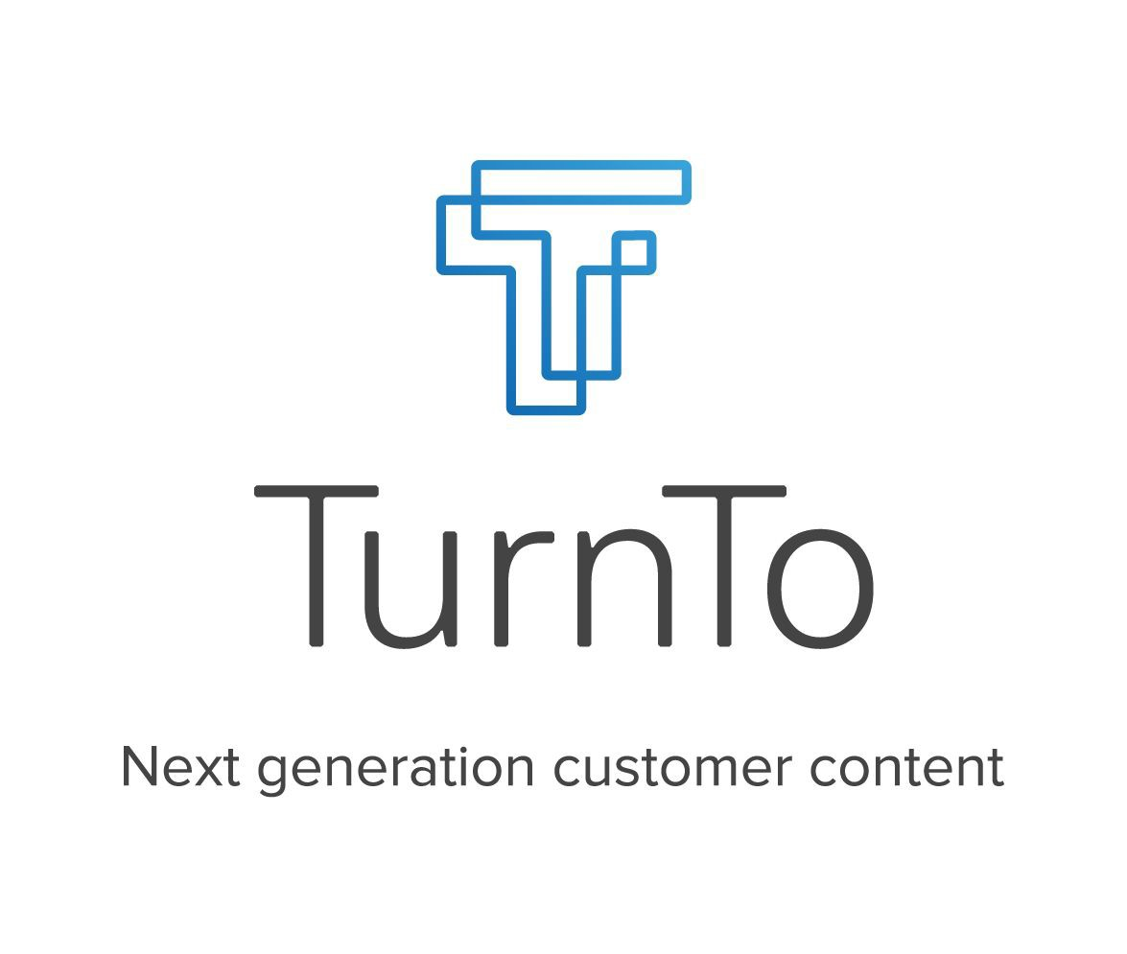

## Table of Contents

Table of Contents 2

Setup 3

Configuration 6

Setting Up Your Site 6

Initial Setup and General Settings 7

Configure the Mobile Landing Page 10

Set up Your Feeds 13

Set up TurnTo Widgets and Teasers 21

Set up Search Settings 27

Custom Code 34

Cartridge Name Adjustment 34

Global Includes 35

Product Detail Page 36

Category and Search Pages 39

Testing Use Cases 49

Q&A Testing 49

Reviews Testing 52

Visual Content Testing 55

Refinements Testing 58

Checkout Comments 58

## Setup

**IMPORTANT NOTE: This document contains the integrating instructions for non-SFRA architecture only using either controllers or pipelines. Please refer to the SFRA document for a complete SFRA installation. Please NOTE that pipelines are not officially supported in the updated cartridge.**

**Architecture Overview**

This TurnTo® LINK integration contains three cartridges, named int\_turnto\_sfra, int\_turnto\_controllers and int\_turnto\_core. The “int\_turnto\_controllers” cartridge will not be used with SFRA. The “int\_turnto\_sfra” cartridge will be used with this Legacy implementation. The controllers cartridge has two controllers called TurnTo.js and TurnToSSO.js, which contains all of logic used to render TurnTo content and enable single sign on (i.e. SSO). The TurnTo controller contains five entry points: GetProductQA, GetProductReviews, MobileLanding, VisualContentsPinboard, CheckoutCommentsPinboard.

**Localization**

The cartridge supports localization for all jobs. Each job will loop through all enabled locales for the current job scoped site. An SFCC site and product catalog supports multiple locales per instance and are mapped to multiple distinct TurnTo sites, each with their own configuration and one locale per site.

**Export and Import Jobs**

The int\_turnto\_core contains the TurnTo Feeds entry points, which contain a JS script that is used for jobs.

**ExportHistoricalOrders**

The ExportHistoricalOrders entry point exports all of the customer orders that have been placed in the last X days (this number is configurable via site preference). The exported data is then automatically pushed to the TurnTo® system via HTTP. A temporary file, named “exportOrders.txt”, is written to a TurnTo folder within the Import/Export folder

Example: “[your\_sandbox\_url]/Impex/TurnTo/[locale]/exportOrders.txt”

The file is left on the files system after the job is finished. The file is overwritten each time the export job is run.

**ExportHistoricalOrdersByDate**

The ExportHistoricalOrdersByDate entry point exports all of the customer orders that have been placed on X date (this date is configurable via site preference). This job is meant to be manually run, in the event that order(s) from a specific date were not uploaded successfully in the past. The exported data is then automatically pushed to the TurnTo® system via HTTP. A temporary file, named “exportOrder.txt”, is written to a TurnTo folder within the Import/Export folder.

Example: “[your\_sandbox\_url]/Impex/TurnTo/[locale]/exportOrders.txt”

The file is left on the files system after the job is finished. The file is overwritten each time the export job is run.

**ExportCatalog**

The ExportCatalog entry point exports all of the products from the catalog. The exported data is then automatically pushed to the TurnTo® system. A temporary file, named “exportCatalog.txt”, is created in a TurnTo folder within the Import/Export folder.

Example: “[your\_sandbox\_url]/Impex/TurnTo/[locale]/exportCatalog.txt”

The file is left on the files system after the job is finished. The file is overwritten each time the export job is run.

**ImportAverageRatings**

The ImportAverageRatings entry point imports all of the average star ratings for your product SKUs from the SKU-to-Average Star Rating Feed.

All data is reset before the import.

**NOTE: You will need to contact your TurnTo® support representative to enable this feed.**

**ImportUserGeneratedContent**

The ImportUserGeneratedContent entry point imports all of the user-generated content (Questions, Answers, Replies, Comments, and Reviews) for all items on your site, and stores it in a searchable attribute on the product data.

All data is reset before the import.

**NOTE: You will need to contact your TurnTo® support representative to enable the XML version of this feed.**

## Configuration

### Setting Up Your Site

1. Create a TurnTo account on [www.turnto.com/register](http://www.turnto.com/register) if you don't already have one.
2. Make sure your TurnTo contact has added your site to the [turnto.com](http://turnto.com/) system.
3. Make sure your TurnTo contact has made you a TurnTo account manager of your site. Once you are a manager of your site, you will see a new navigation area on the left with your site name and links to your settings, reporting and moderation.
4. Add cartridges to site cartridge path
   1. In Business Manager, Click Sites in the Administration section
   2. Click "Manage Sites" link
   3. Click the name of your site. For instance, SiteGenesis.
   4. Click the "Settings" tab.
   5. Using legacy architecture, fill in the cartridge field with the following as: int\_turnto\_controllers:int\_turnto\_core:[site\_siteid]:[app\_storefront\_base]

**NOTE*: replace cartridges in brackets with your site level and base cartridges.***

* 1. Click Apply

1. The import/export jobs require the use of the SFCC job components cartridge, which has a cartridge name “bc\_job\_components”. This will need to be downloaded from the SFCC repo and added to your workspace.
2. SFCC repo -> <https://github.com/SalesforceCommerceCloud/job-components>
3. Add cartridges to business manager cartridge path
   1. In Business Manager, Click Sites in the Administration section
   2. Click "Manage Sites" link
   3. Click the "Business Manager" link
   4. Using legacy architecture, fill in the cartridge field with the following as: int\_turnto\_controllers:int\_turnto\_core:bc\_job\_components  
      **NOTE: bc\_job\_components will need to be added, see Step 5 above**
   5. Click Apply

### Initial Setup and General Settings

#### Upload and Import Metadata

1. In Business Manager, click "Site Development" in the Administration section
2. Click "Import & Export" and then, under the section Import & Export Files, click "Upload"
3. Choose the file located in *metadata/TurnToMetaData.xml* and click "Upload"
4. Return back to the "Import & Export" page, and then, under Meta Data, click "Import"
5. Select the file you just uploaded, and click "Next". Once the file validates, click "Import"

#### Upload and Import Job Schedules

1. Open the file *metadata/TurnToJobSchedules\_Controllers.xml*, and edit it.
2. Modify all references to site-id="SiteGenesis" in the file, replacing them with the ID of your site
3. In Business Manager, click "Operations" in the Administration section
4. Click "Import & Export" and then, under the section Import & Export Files, click "Upload"
5. Choose the file you just edited, and click "Upload"
6. Return back to the "Import & Export" page, and then, under Job Schedules, click "Import"
7. Select the file you just uploaded, and click "Next". Once the file validates, click "Import"

#### Upload and Import Services

1. In Business Manager, click "Operations" in the Administration section
2. Click "Import & Export" and then, under the section Import & Export Files, click "Upload"
3. Choose the file located in *metadata/TurnToServices.xml* and click "Upload"
4. Return back to the "Import & Export" page, and then, under Services, click "Import"
5. Select the file you just uploaded, and click "Next". Once the file validates, click "Import"

#### TurnTo General Settings

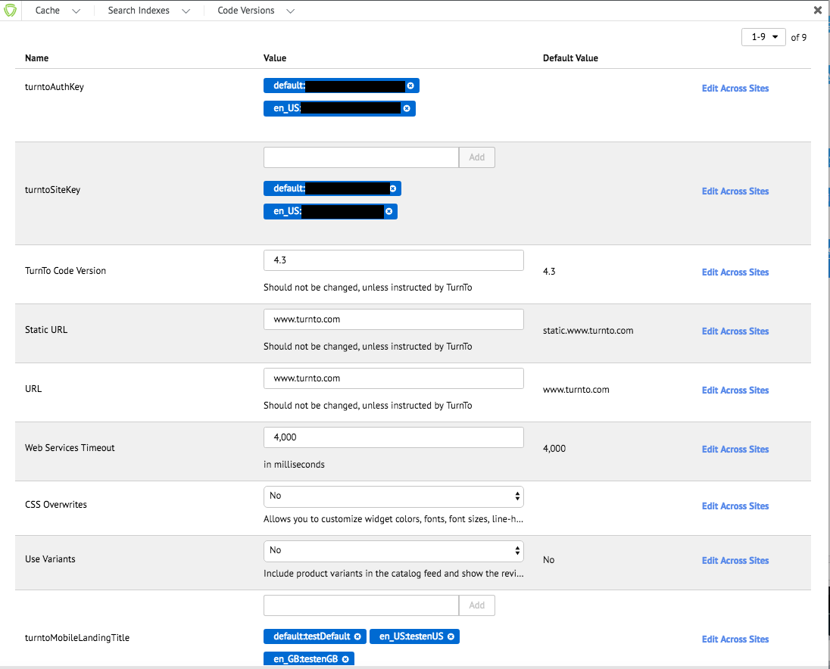

**NOTE: Notice localized variables auth and site key and mobile landing title.**

1. In Business Manager, click "Custom Preferences" in the Merchant Tools section, under Site Preferences
2. Click on "TurnTo General Settings" and then fill out the following information (\* means required):
   1. Auth Key\*: <YOUR AUTH KEY> (Your Auth Key will be provided by your TurnTo Customer Success Manager) Must be in the following format -> [locale]:[auth\_key]
   2. Site Key\*: <YOUR SITE KEY> (Your Site Key will be provided by your TurnTo Customer Success Manager) Must be in the following format -> [locale]:[site\_key]
   3. TurnTo Code Version: This number will replace the version number in the JS script URLs, default is 4.3 (Should not be changed, unless instructed by TurnTo)



* 1. Static URL: default is "[static.www.turnto.com](http://static.www.turnto.com/)" (**NOTE: no http:// or https:// or trailing slashes**)
  2. URL: default is "[www.turnto.com](http://www.turnto.com/)" (**NOTE: no http:// or https:// or trailing slashes**)
  3. Web Services Timeout: number of milliseconds before services time out, default is 4000
  4. CSS Overwrites: "Yes" if you want to be able to customize the widgets, "No" otherwise
  5. Use Variants – Set to ‘Yes’ to include product variants in the catalog feed and show the reviews for individual variants on the product details page. Reviews for other variants will be shown as related reviews. Default is ‘No’
  6. Turnto Mobile Landing Title: This will be the title of the mandatory Mobile Landing Page, default is "Mobile Landing Page Title" Must be in the following format -> [locale]:[mobile\_landing\_title]

1. Click Apply

### Configure the Mobile Landing Page

The mobile landing page is required for all TurnTo® implementations - It is a container that displays certain TurnTo® screens for mobile users and is referred to in the functional for all TurnTo® products (documentation: <https://turnto.zendesk.com/hc/en-us/articles/207959416-Mobile-Landing-Page-Required-4-3)>

By default, the Mobile Landing page is included at the TurnTo-MobileLanding pipeline endpoint, i.e. http://<CLIENT DOMAIN>/on/.store/Sites-<SITE NAME>-Site/default/TurnTo-MobileLanding



#### Add the Mobile Landing Page URL to your TurnTo Settings



1. Log in to your TurnTo account and go to the "Q&A Settings" link for your site.

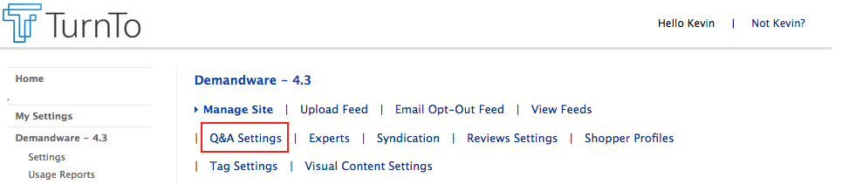

1. Scroll down to the bottom of the page, and enter your Mobile Landing page URL into the field named "TurnTo Mobile Page", and click Update.

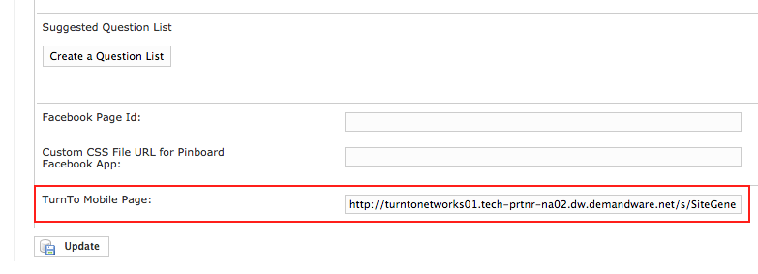

#### Create a Pipeline URL for the Mobile Landing Page in Business Manager (optional)

1. You can create a vanity URL for the MobileLanding pipeline in Business Manager by going to Merchant Tools, <SITE NAME>, Site URLs, URL Rules, and clicking on the "Pipeline URLs" tab.
2. In the "New Alias:" field, add an alias (i.e. "mobilelanding") and the pipeline ("TurnTo-MobileLanding"), and click Apply.

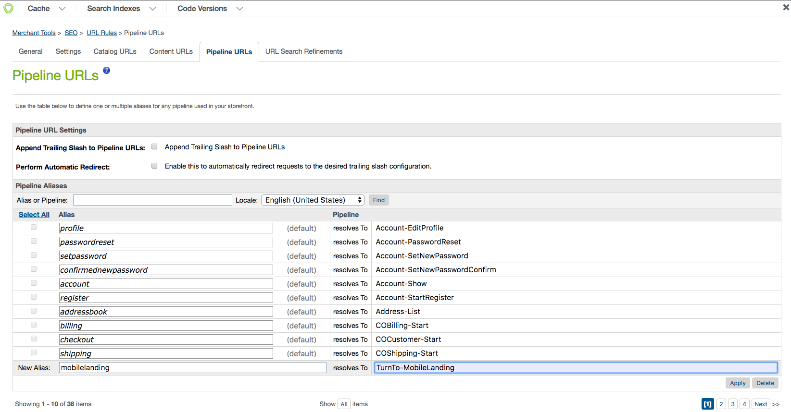

1. Then, go back to the TurnTo® settings page from the previous section, and update the TurnTo Mobile Page field to the new URL.

### Set up Your Feeds

#### Domain Name Setup

**NOTE: A domain name must be added to TurnTo Settings for feeds to be uploaded. Otherwise, there will be an error screen.**

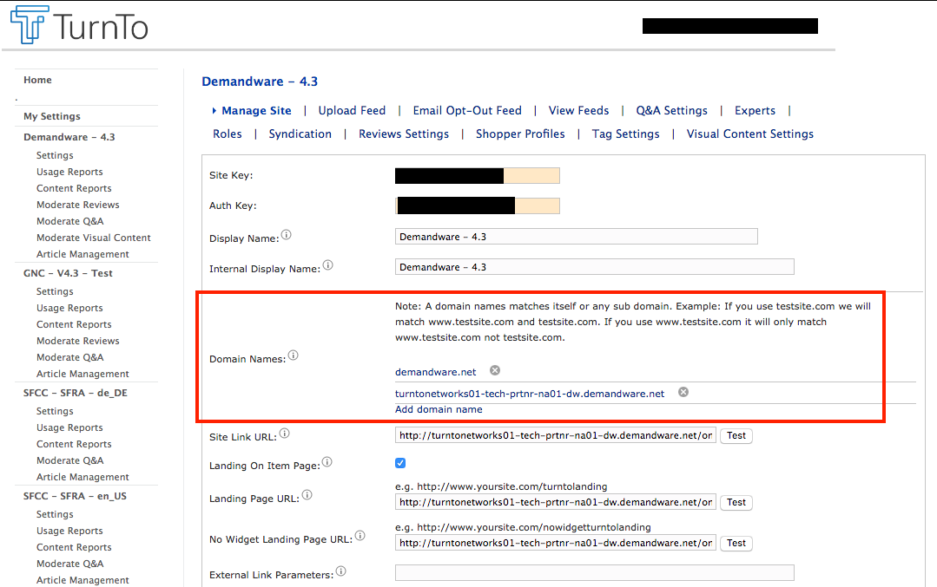

#### TurnTo Javascript Feed

Purpose: Collects real-time order data on the order confirmation page

Documentation: <https://turnto.zendesk.com/hc/en-us/articles/208262393-Javascript-Feed-4-3>

1. In Business Manager, click "Custom Preferences" in the Merchant Tools section, under Site Preferences
2. Click on "TurnTo Feeds" and then fill out the following information:  
   Javascript Feed (on Order Confirmation): "Yes" if you want to enable the collection of real-time order data on the order confirmation page, "No" otherwise
3. Click Apply

#### TurnTo Catalog Export Feed



Purpose: Generates a catalog feed in the TurnTo format and uploads it to [turnto.com](http://turnto.com/) via HTTP for processing.

The catalog export feed is localized and may contain multiple feeds if more than one site level locale is enabled.

Documentation:

<https://turnto.zendesk.com/hc/en-us/articles/208262373-Catalog-Feed-4-3>

**NOTE: The catalog feed includes links to product images. By default, the image store is used. If you use a third party to store your images you’ll need to modify ExportCatalog.js in the int\_turnto\_core cartridge to point to your image store.**

**NOTE: A domain name must be added to TurnTo Settings for feeds to be uploaded. Otherwise, there will be an error screen. See Domain Name Setup.**



1. Login to your Business Manager account
2. Click the Operations link in the Administration section
3. Click Job Schedules
4. Click "TurnToCatalogExport”
5. Configure your desired run frequency, as well as any notifications, and make sure "Enabled" is checked.
6. Verify the steps in the “Step Configurator” are set to the correct site
7. Click Apply
8. Recommendation: Run this job schedule once manually, to perform the initial load of your product catalog into the TurnTo system
9. Recommendation: Configure error handling for your email address for testing.

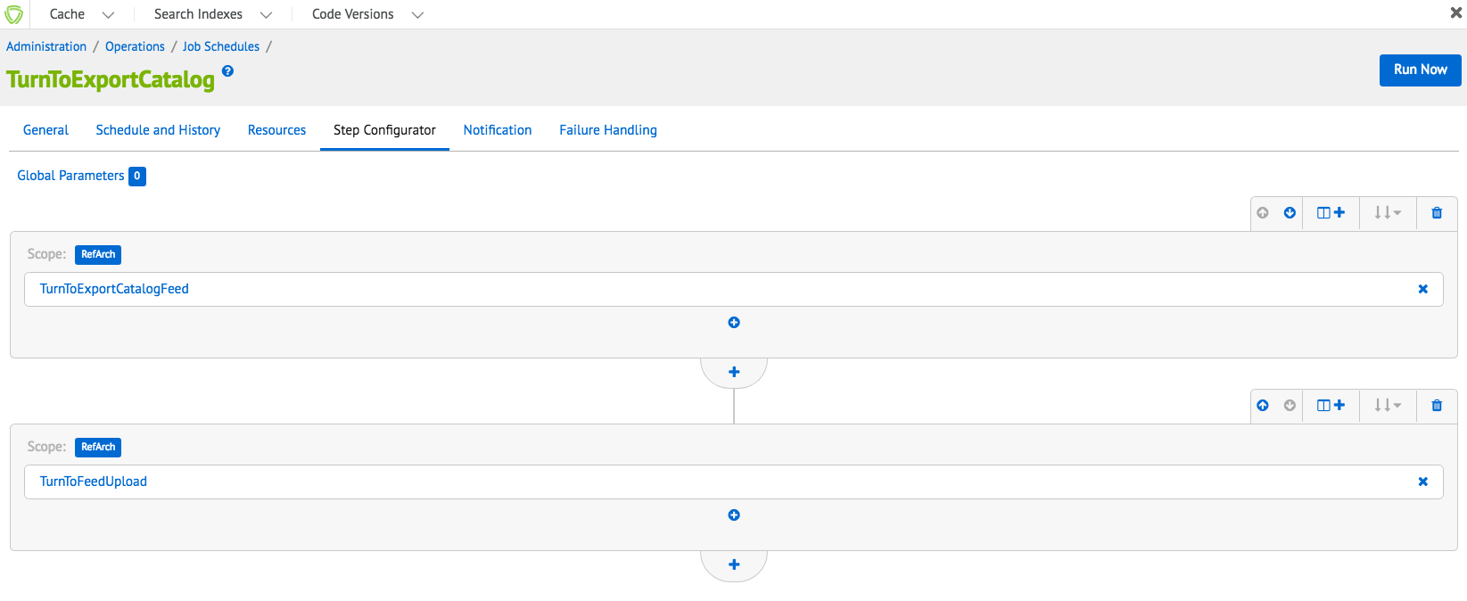

#### 

#### TurnTo Historical Order Feed – Ongoing

Purpose: Generates an order feed in the TurnTo format and uploads it to [turnto.com](http://turnto.com/) via HTTP for processing.

The order export feed is localized and may contain multiple feeds if more than one site level locale is enabled.

Documentation:

<https://turnto.zendesk.com/hc/en-us/articles/207959666-Historical-Order-Feed-4-3>

**NOTE: A domain name must be added to TurnTo Settings for feeds to be uploaded. Otherwise, there will be an error screen. See Domain Name Setup.**

1. Login to your Business Manager account
2. Click the Site Preferences Link in the Merchant Tools section for your site
3. Click Custom Preferences and then TurnTo Feeds
4. Update the "Historical Order Days" preference to the number of days you want to be exported (typically 2 or 3)
5. Click the Operations link in the Administration section
6. Click Job Schedules
7. Click "TurnToHistoricalOrderExportOngoing”
8. Configure your desired run frequency, as well as any notifications, and make sure "Enabled" is checked
9. Verify the steps in the “Step Configurator” are set to the correct site
10. Click Apply
11. Recommendation: Configure error handling for your email address for testing.

#### TurnTo Historical Order Feed - Specific Date (Optional)

Purpose: Generates an order feed for a specific date in the TurnTo format and uploads it to [turnto.com](http://turnto.com/) via HTTP for processing. This job is meant to be run manually, in the event that orders were skipped by the JS Feed or the Historical Feed - Ongoing.

The specific date order export feed is localized and may contain multiple feeds if more than one site level locale is enabled.

Documentation: <https://turnto.zendesk.com/hc/en-us/articles/207959666-Historical-Order-Feed-4-3>

**NOTE: A domain name must be added to TurnTo Settings for feeds to be uploaded. Otherwise, there will be an error screen. See Domain Name Setup.**

1. Login to your Business Manager account
2. Click the Site Preferences link in the Merchant Tools section for your site
3. Click Custom Preferences and then TurnTo Feeds
4. Update the "Historical Order Date" preference to the specific date you want to export
5. Click the Operations link in the Administration section
6. Click Job Schedules
7. Click "TurnToHistoricalOrderExportSpecificDate"
8. Verify the steps in the “Step Configurator” are set to the correct site
9. Click "Run"
10. Recommendation: Configure error handling for your email address for testing.

#### Multiple Locale Feed Setup

**NOTE: If your site has multiple locales, the feeds can be localized if setup in Business manager and in TurnTo.**

Download (for Reviews and UGC jobs)

1. Contact your TurnTo support representative to enable multiple locales for your TurnTo setup.
2. Each locale will have separate auth and site keys. These keys can be obtained from the TurnTo portal
3. Add the auth and site keys in the Business Manager custom site preference folder “TurnTo General Settings”. See the following screenshot for a sample of the format:

Site and Auth key format

[locale]:[site\_or\_auth\_key]

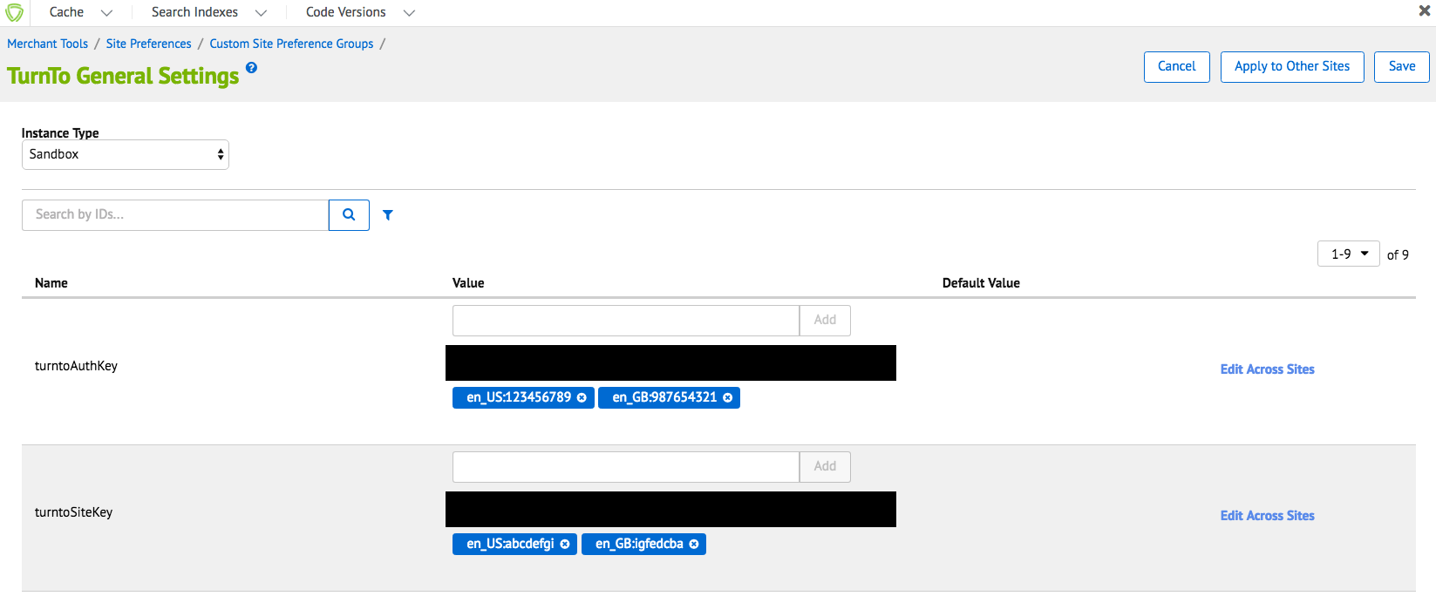

Each download feed URL will contain the unique auth and site keys to distinguish locales.

Download Feed Example (for Reviews and UGC): [http://www.turnto.com/static/export/YOURSITEKEY/YOURAUTHKEY/turnto-ugc.xml](http://www.turnto.com/static/export/YOURSITEKEY/YOURAUTHKEY/turnto-ugc.xml" \t "_blank)

Upload (for Catalog and Order Export jobs)

**NOTE: The following steps are the same as the previous Download section.**

1. Contact your TurnTo support representative to enable multiple locales for your TurnTo setup.
2. Each locale will have separate auth and site keys. These keys can be obtained from the TurnTo portal
3. Add the auth and site keys in the Business Manager custom site preference folder “TurnTo General Settings”. See the following screenshot for a sample of the format:

Upload Feed Example (for Catalog and Orders exports): <http://www.turnto.com/feedUpload/postfile>

The URL is not unique per locale, instead the content request body will contain multiple HTTP request parts to distinguish the locale using both site and auth keys.

Content HTTP Request parts

1. File -> locale specific file to upload
2. SiteKey -> locale specific site key
3. AuthKey -> locale specific auth key
4. Feed Style -> always the following string “tab-style.1”

#### TurnTo SKU-to-Average Rating Feed (Optional)

Purpose: Downloads and imports the nightly sku-to-average-rating feed for display of teaser on the category/search pages

**NOTE: In order to use this job, the steps in “Custom Job Components“ must be completed.**

**NOTE: If your site has multiple locales, the feeds can be localized if setup in Business manager.**

Documentation (see "Option #1"): <https://turnto.zendesk.com/hc/en-us/articles/208262323-SKU-to-Average-Rating-Feed-Optional-4-3>

1. Enable the Sku Average Rating Feed Pull in your TurnTo Settings. (Contact your TurnTo support representative to enable.)
2. After the nightly feed is generated, verify that you can access the feed via a browser at: <http://static.www.turnto.com/static/export/YOURSITEKEYHERE/YOURAUTHKEYHERE/turnto-skuaveragerating.xml>
3. Login to your Business Manager account



1. Click the Operations link in the Administration section
2. Click Job Schedules
3. Click "TurnToImportAverageRatings"
4. Configure your desired run frequency, as well as any notifications, and make sure "Enabled" is checked.
5. Verify the steps in the “Step Configurator” are set to the correct site
6. Click Apply
7. After the job has successfully run, products present in the feed will have the following custom attributes populated on the Product record:  
   turntoAverageRating  
   turntoReviewCount  
   turntoRelatedReviewCount  
   turntoCommentCount
8. Recommendation: Configure error handling for your email address for testing.

#### TurnTo User Generated Content Feed (Optional)

Purpose: Downloads and imports the Customer Generated Content XML feed for all products, so that the TurnTo content can be searchable on the storefront.

**NOTE: In order to use this job, the steps in “Custom Job Components“ must be completed.**

**NOTE: If your site has multiple locales, the feeds can be localized if setup in Business manager.**

Documentation: <https://turnto.zendesk.com/hc/en-us/articles/208262293-CGC-Feed-SEO-4-3>

1. Contact your TurnTo support representative to enable the XML version of the sitewide Customer Generated Content Feed.
2. After the nightly feed is generated, verify that you can access the feed via a browser at: <http://static.www.turnto.com/static/export/YOURSITEKEYHERE/YOURAUTHKEYHERE/turnto-ugc.xml>
3. Login to your Business Manager account
4. Click the Operations link in the Administration section
5. Click Job Schedules
6. Click "TurnToImportUserGeneratedContent"
7. Configure your desired run frequency, as well as any notifications, and make sure "Enabled" is checked.
8. Verify the steps in the “Step Configurator” are set to the correct site
9. Click Apply
10. After the job has successfully run, products present in the feed will have the following custom attributes populated on the Product record:  
    turntoUserGeneratedContent
11. Recommendation: Configure error handling for your email address for testing.

### Set up TurnTo Widgets and Teasers

#### TurnTo Q&A

Features Include:

* Q&A & Reviews Combo Teaser (if both are enabled): <https://turnto.zendesk.com/hc/en-us/articles/207959326-Q-A-and-Reviews-Displaying-the-Q-A-Teaser-and-Reviews-Teaser-on-the-same-line-4-3>
* Q&A Teaser (if only Q&A is enabled): <https://turnto.zendesk.com/hc/en-us/articles/208272843-Q-A-Custom-Item-Teaser-Launching-Widget-From-Under-a-Tab-4-3>

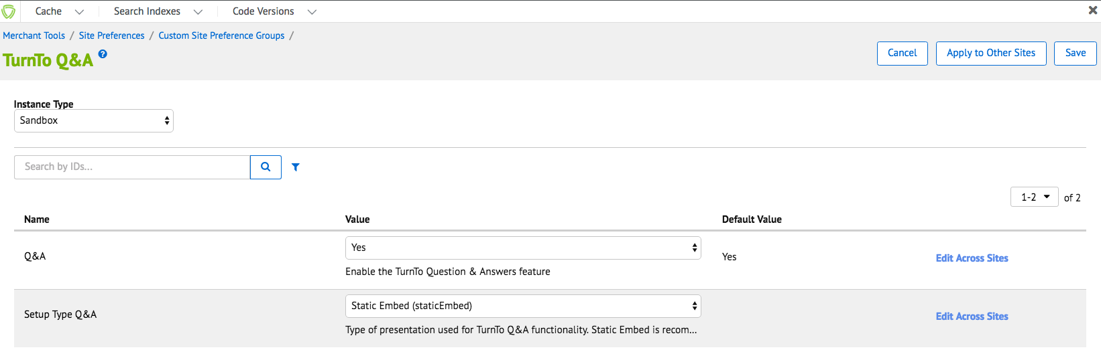

1. In Business Manager, click "Custom Preferences" in the Merchant Tools section, under Site Preferences
2. Click on "TurnTo Q&A" and then fill out the following information:
3. Q&A: "Yes" if you want to enable the Question & Answers feature, "No" otherwise
4. Setup Type Q&A: Type of presentation used for TurnTo Q&A functionality.
   1. "Static Embed" is recommended for SEO benefits. The reason static embed is better for SEO is that it serves up a locally cached version of Q&A that is updated every session so robots can crawl the pages. Dynamic embed is updated constantly and not cached so it cannot be crawled.
5. Click Apply

#### TurnTo Reviews

Features Include:

* Q&A & Reviews Combo Teaser (if both are enabled): <https://turnto.zendesk.com/hc/en-us/articles/207959326-Q-A-and-Reviews-Displaying-the-Q-A-Teaser-and-Reviews-Teaser-on-the-same-line-4-3>
* Reviews Teaser (if only Reviews are enabled): <https://turnto.zendesk.com/hc/en-us/articles/208262133-Reviews-Custom-Teaser-Launching-Widget-Under-a-Tab-4-3>

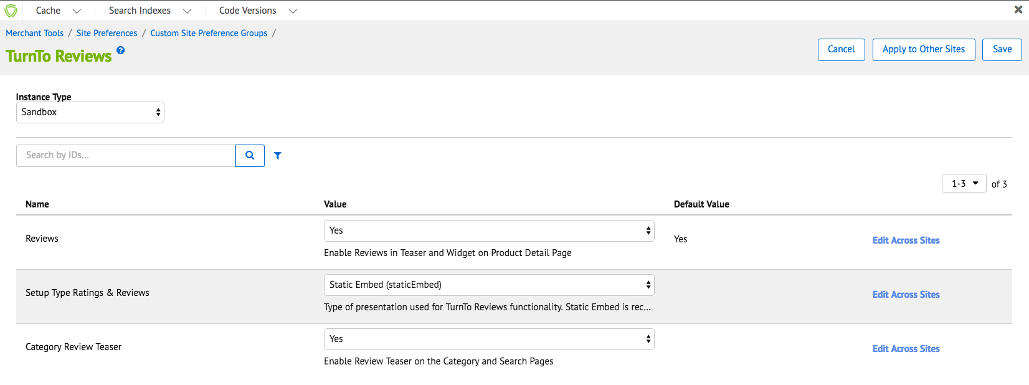

1. In Business Manager, click "Custom Preferences" in the Merchant Tools section, under Site Preferences
2. Click on "TurnTo Reviews" and then fill out the following information:
3. Reviews: "Yes" if you want to enable the Reviews feature on the product detail page, "No" otherwise
4. Setup Type Ratings & Reviews: How TurnTo Reviews are integrated into your site. "Static Embed" is recommended for SEO benefits.
   1. "Static Embed" is recommended for SEO benefits. The reason static embed is better for SEO is that it serves up a locally cached version of Q&A that is updated every session so robots can crawl the pages. Dynamic embed is updated constantly and not cached so it cannot be crawled.
5. Category Review Teaser: "Yes" if you want to enable the review teaser on the category and search pages, "No" otherwise
6. Click Apply

#### TurnTo Visual Content

Features Include:

* Visual Content Gallery Row Widget: <https://turnto.zendesk.com/hc/en-us/articles/207702936-Visual-Content-Gallery-Row-Widget>
* Visual Content Pinboard:  
  <https://turnto.zendesk.com/hc/en-us/articles/210589443-Visual-Content-Pinboard-4-3>

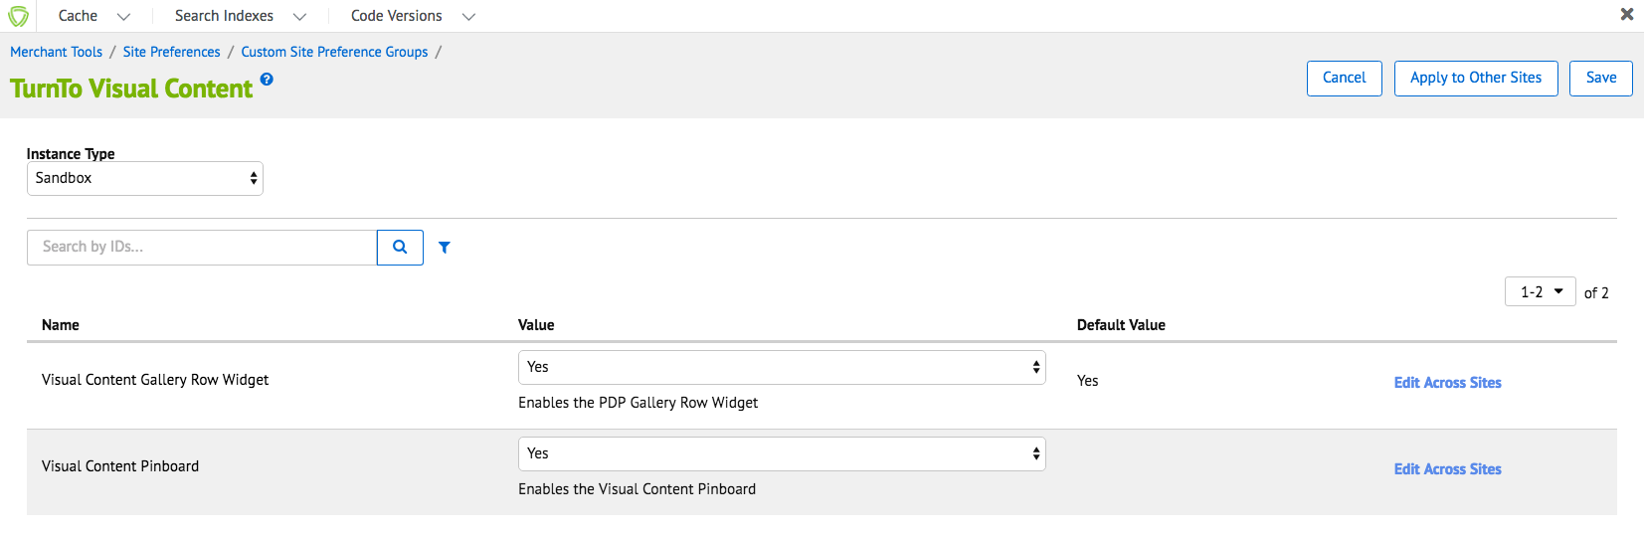

1. In Business Manager, click "Custom Preferences" in the Merchant Tools section, under Site Preferences
2. Click on "TurnTo Visual Content" and then fill out the following information:
3. Visual Content Gallery Row Widget: "Yes" if you want to enable the PDP Gallery Row Widget, "No" otherwise.
4. Visual Content Pinboard: "Yes" if you want to enable the Visual Content Pinboard, "No" otherwise.  
   By default, the Visual Content Pinboard page is included at the TurnTo-VisualContentPinboard pipeline endpoint, i.e. http://<CLIENT DOMAIN>/on/.store/Sites-<SITE NAME>-Site/default/TurnTo-VisualContentPinboard
5. Click Apply

#### 

#### TurnTo Checkout Comments

Features Include:

* Checkout Comments Capture Widget: <https://turnto.zendesk.com/hc/en-us/articles/208258993-Comment-Capture-Widget-4-3>
* Checkout Comments PDP Widget: <https://turnto.zendesk.com/hc/en-us/articles/208259113-Checkout-Comments-PDP-Widget-4-3>
* Checkout Comments Pinboard:  
  <https://turnto.zendesk.com/hc/en-us/articles/209186526-Checkout-Comments-Pinboard-4-3>
* Checkout Comments Pinboard Teaser: <https://turnto.zendesk.com/hc/en-us/articles/211770063-Checkout-Comments-Pinboard-Teaser-4-3>

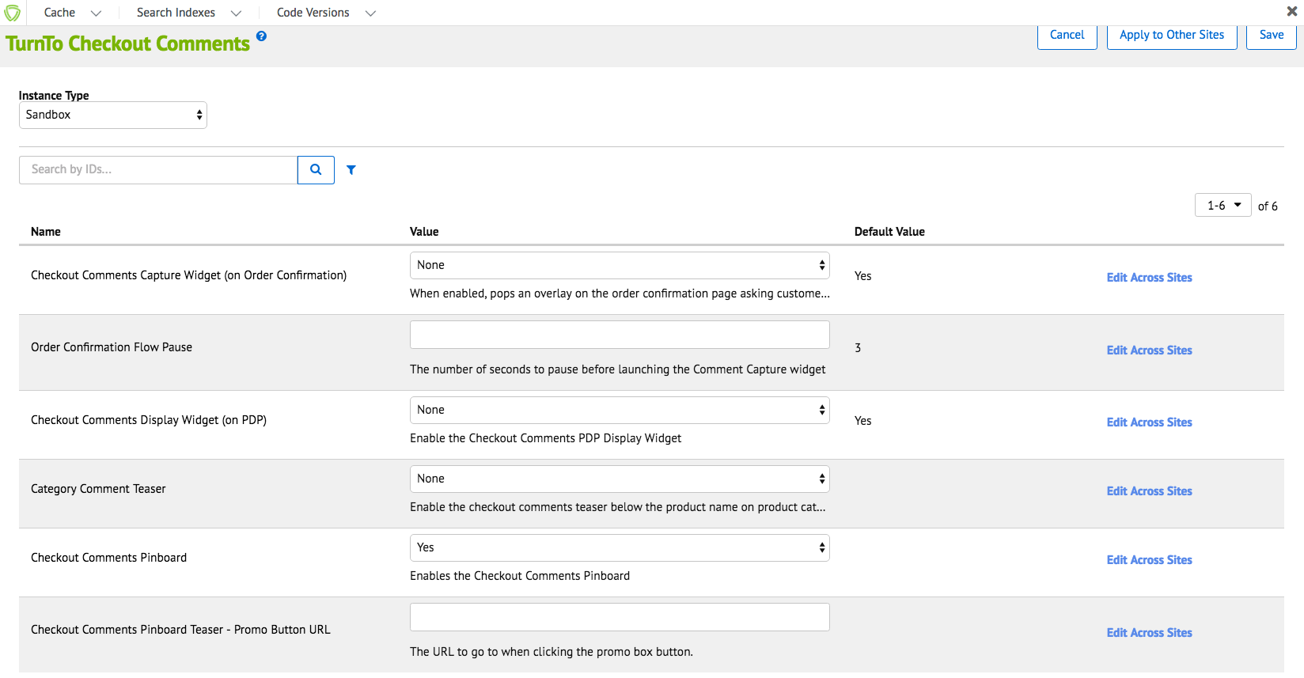

1. In Business Manager, click "Custom Preferences" in the Merchant Tools section, under Site Preferences
2. Click on "TurnTo Checkout Comments" and then fill out the following information:
   1. Checkout Comments Capture Widget (on Order Confirmation): When enabled, asks customers on the order confirmation page why they decided to buy each item they purchased
   2. Order Confirmation Flow Pause: The number of seconds to pause before launching the Comment Capture widget, default is 3
   3. Checkout Comments Display Widget (on PDP): "Yes" if you want to enable the checkout comments widget on the product detail page, "No" otherwise
   4. Category Comment Teaser: "Yes" if you want to enable the checkout comments teaser below the product name on category/search pages, "No" otherwise
   5. Checkout Comments Pinboard: "Yes" if you want to enable the checkout comments pinboard and pinboard teaser, "No" otherwise  
      By default, the Checkout Comments Pinboard page is included at the TurnTo-CheckoutCommentsPinboard pipeline endpoint, i.e. http://<CLIENT DOMAIN>/on/.store/Sites-<SITE NAME>-Site/default/TurnTo-CheckoutCommentsPinboard
   6. Checkout Comments Pinboard Teaser Promo Button URL: The URL to go to when clicking the promo box button in the checkout comments pinboard teaser
3. Click Apply

TurnTo Checkout Comments Pinboard Teaser

In order to get the pinboard teaser working on the category pages, it needs to be enabled for each category you would like it to appear on.

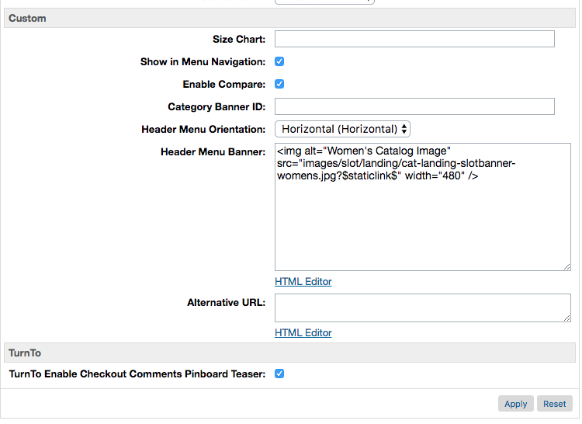

1. In Business Manager, click "Products and Catalogs" in the Merchant Tools section
2. Click Catalogs, then click your site's storefront catalog
3. Navigate to the category you want to enable the teaser for, and then click "Edit"
4. Click the "Category Attributes" tab
5. Find the "TurnTo Enable Checkout Comments Pinboard Teaser" attribute, and check it.
6. Click Apply
7. The category page will only show the pinboard teaser if ALL of the following conditions are met:
   1. Custom site preference "Checkout Comments Pinboard" under the TurnTo Checkout Comments group is set to true
   2. Custom site preference "Checkout Comments Pinboard Teaser - Promo Button URL" under the TurnTo Checkout Comments group has a value
   3. Custom category attribute "TurnTo Enable Checkout Comments Pinboard Teaser" is set to true
   4. The category contains at least 4 products (as defined by the Catalog Feed) with 4 buyer comments. This minimum requirement is on the TurnTo side, and can not be changed.

### Set up Search Settings

#### Make User Generated Content Searchable

**NOTE: The necessary data comes from the User Generated Content Feed.**

1. Login to your Business Manager account
2. Click the Search link under Merchant Tools for your site
3. Click Searchable Attributes
4. Click "New" and add attribute "custom.turntoUserGeneratedContent" to the list, then give it an appropriate Boost Factor
5. Click Apply

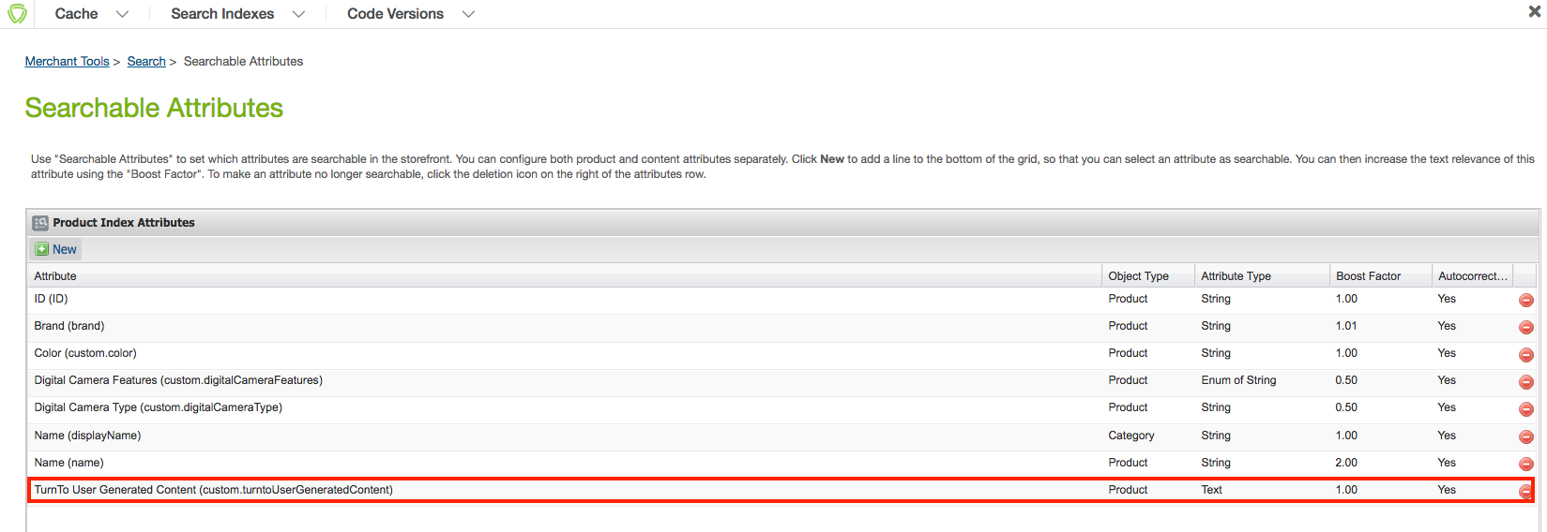

1. Under the Business Manager header, click Search Indexes
2. Check the box for "Product Index" and click Rebuild
3. Now, when you search for specific text that exists in a review, comment, or question, the matching products will show up in the search results.

The following is the result, notice the word “fantastic” is in the UGC attribute and the product shows up in the search.

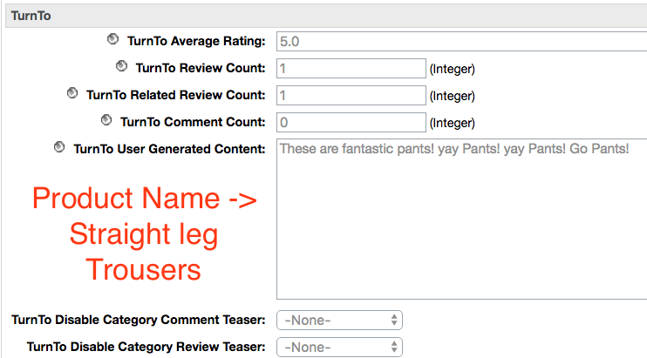

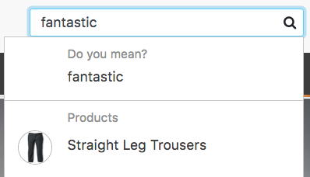

#### 

#### Configure Average Star Ratings as a Search Refinement

**NOTE: The necessary data comes from the SKU-to-Average-Rating Feed.**

1. Login to your Business Manager account
2. Click the Products and Catalogs link under Merchant Tools for your site
3. Click Catalogs
4. Click the storefront catalog of your site, and then click "Edit" on the top right
5. Click the tab for Search Refinement Definitions, and click "New"

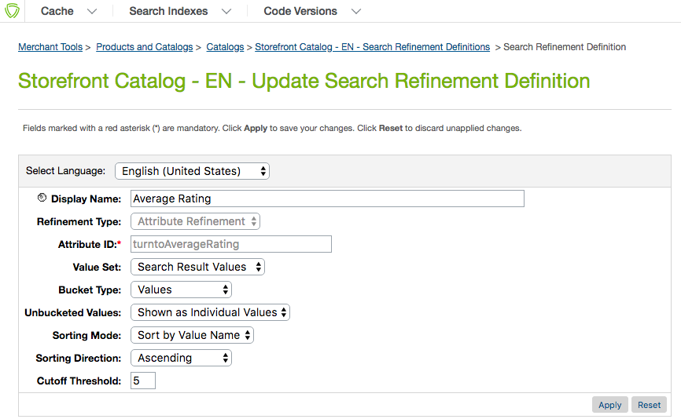

1. Update the following settings:
   1. Display Name: Average Rating
   2. Refinement Type: Attribute Refinement
   3. Attribute ID: turntoAverageRating
   4. Value Set: Search Result Values
   5. Bucket Type: Values
   6. Unbucketed Values: Show as Individual Values
   7. Sorting Mode: Sort by Bucket Position
   8. Sorting Direction: Ascending
   9. Cutoff Threshold: 5
2. Click Apply
3. Under Attribute Bucket Refinements, add the following buckets as shown in the image below:

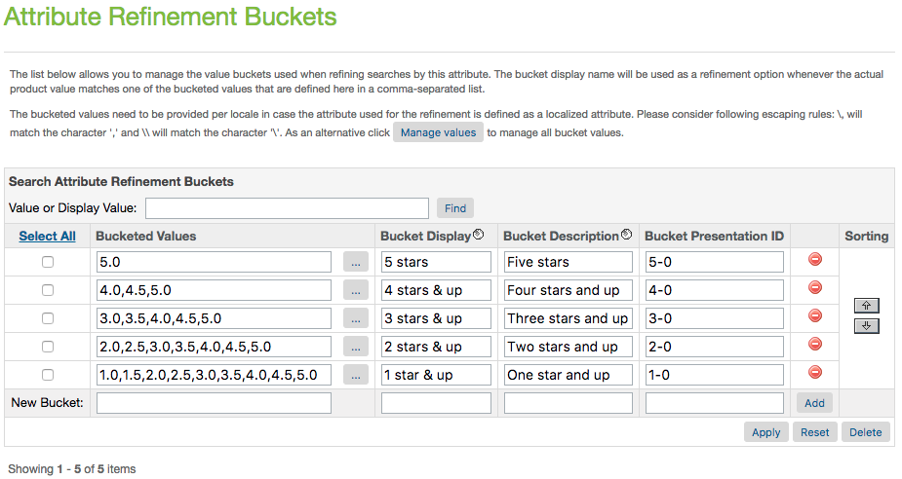

1. Click Apply
2. Under the Business Manager header, click Search Indexes
3. Check the box for "Product Index" and click Rebuild
4. You should now see the refinement for Average Rating on your category and search pages, as seen below:

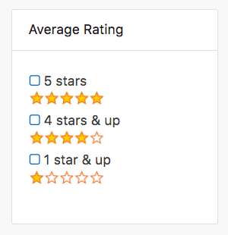

#### Configure Average Star Ratings as a Sortable Filter

**NOTE: The necessary data comes from the SKU-to-Average-Rating Feed.**

1. Login to your Business Manager account
2. Click the Search link under Merchant Tools for your site
3. Click Sorting Rules
4. Click "New" to add a new sorting rule, with the following settings:  
   ID: turnto-ratings  
   Description: Sorts by TurnTo Average Rating
5. With "turnto-ratings" now selected, click Add to add attributes.
6. Select the attribute "TurnTo Average Rating (product.custom.turntoAverageRating), sort direction by "Descending", text relevancy "N/A", and click Apply.

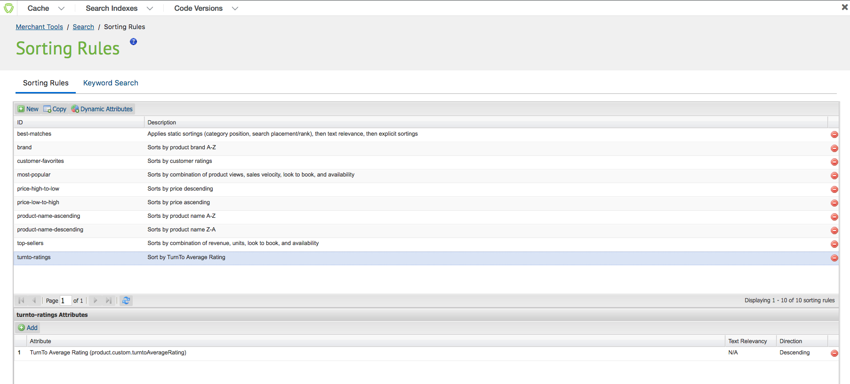

1. Go back to Search, under the Merchant Tools for your site
2. Click Storefront Sorting Options
3. Add a new sorting option, with the following settings:  
   ID: ratings  
   Sorting Rule: turnto-ratings  
   Display Name: Average Rating



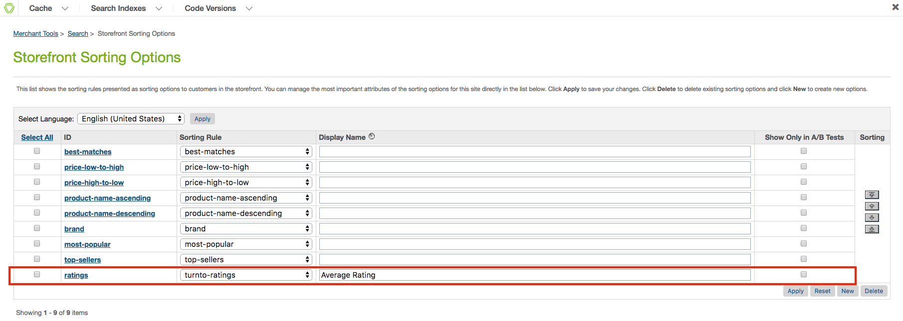

1. Click Apply
2. Under the Business Manager header, click Search Indexes
3. Check the box for "Product Index" and click Rebuild
4. You should now see the refinement for Average Rating on your category and search pages, as seen below:

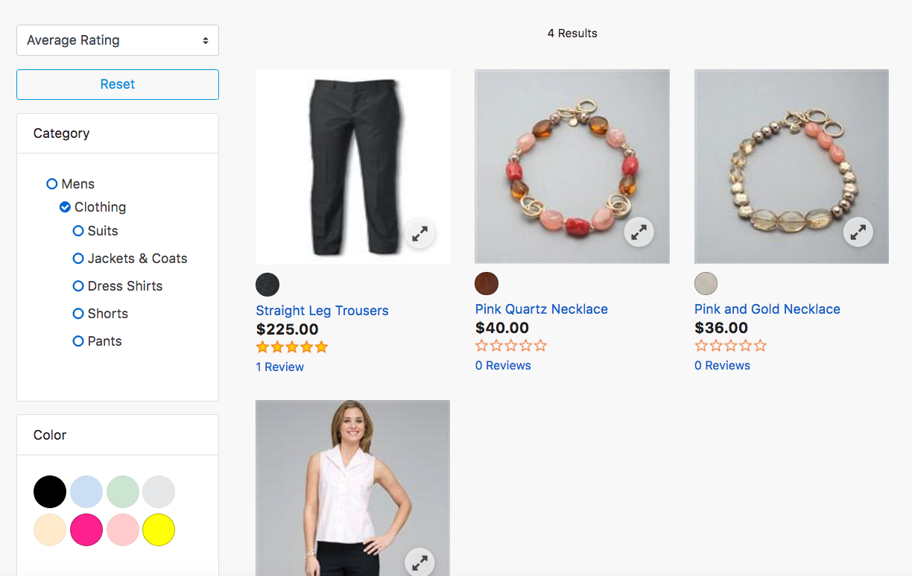

## Custom Code

This section describes the custom code that will need to be added to your storefront. For more information, refer to <http://www.turnto.com/docs> or contact your TurnTo® representative.

### Cartridge Name Adjustment

1. Modify the int\_turnto\_controllers/cartridge/controllers/TurnTo.js to require the correct storefront package for your implementation:

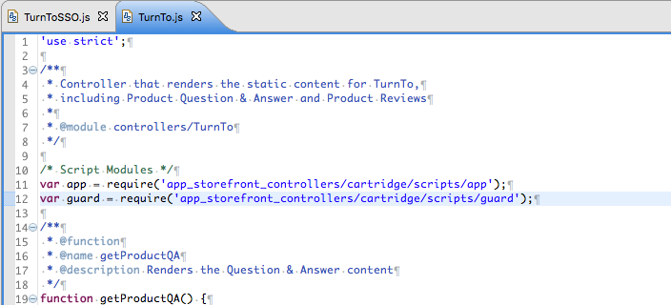

1. Modify the int\_turnto\_controllers/cartridge/controllers/TurnToSSO.js to require the correct storefront package for your implementation:

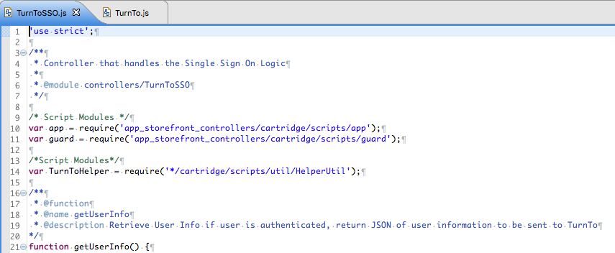

### Global Includes

This section requires you have UX Studio setup and linked to your site. See <https://xchange.demandware.com/docs/DOC-1936> for details.

1. Log in to [www.turnto.com](http://www.turnto.com/) and click on Settings beneath your site name in the left navigation. Copy your "SiteKey" and "AuthKey" from the Manage Site area, and paste them into the associated Custom Site Preferences described in the previous section. These keys will be used in turnToConfig javascript objects to identify you to our systems.
2. In UX Studio, open the following template in your storefront cartridge: *templates/default/components/header/htmlhead.isml*
3. Add the following code to the bottom of the template file you opened in step 2:

<isinclude template="turnto/htmlheadinclude"/>

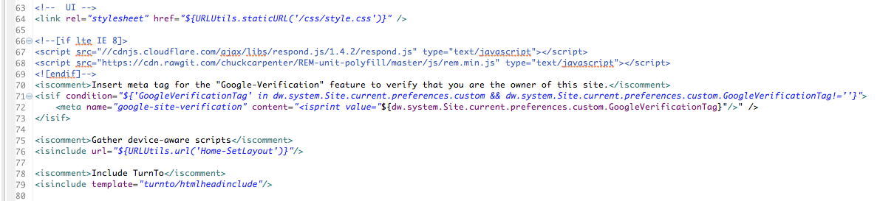

1. Now open the following template in your storefront cartridge: *templates/default/checkout/confirmation/confirmation.isml*
2. Add the following code to the bottom of the template you opened in step 4:  
   <iscomment>Include TurnTo Post Purchase Widget</iscomment>  
   <isinclude template="turnto/confirmationinclude"/>

The result will look like this:

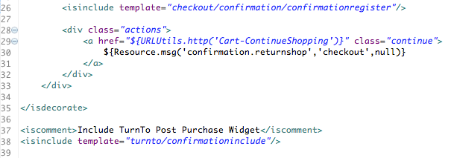

1. The css for the TurnTo widget is in *int\_turnto\_core/cartridge/static/default/css/turnto.css*. Feel free to modify it to your liking.
2. Flush Site cache
   1. In Business Manager, Click Sites in the Administration section.
   2. Click "Manage Sites" link.
   3. Click the name of your site. For instance, SiteGenesis.
   4. Click the "Cache" tab.
   5. Invalidate all caches by clicking the "Invalidate" buttons.
3. Flush Business Manager cache
   1. In Business Manager, Click Sites in the Administration section.
   2. Click "Manage Sites" link.
   3. Click the "Business Manager" link.
   4. Click the "Cache" tab
   5. Invalidate all caches by clicking the "Invalidate" buttons.

### Product Detail Page

#### Teasers (Q&A, R&R)

1. In UX Studio, open the following template in your storefront cartridge: *templates/default/product/productcontent.isml*
2. Add the following code at the bottom of the template, in the template you opened in step 1:  
     
   <isinclude template="product/components/turntoteasers"/>  
     
   The result will look like this:

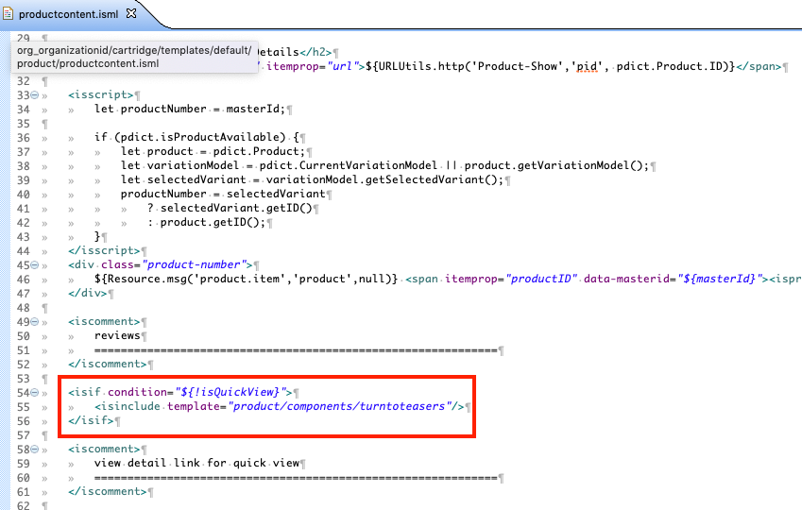



1. If you want bundles and product sets to have the teaser too, add the same code snippet to the following template in your storefront cartridge after the h1 element with class name “product-name”: *templates/default/product/producttopcontentPS.isml*

#### Widgets (Q&A, R&R, Checkout Comments, Visual Gallery Row)

1. In UX Studio, open the following template in your storefront cartridge: *templates/default/product/producttopcontent.isml*
2. Add the following code at the END of the template you opened in step 1, before the closing </isif>:  
     
   <iscomment>TurnTo Widgets</iscomment>  
   <isinclude template="product/widgets"/>
3. Add the following code to the template you opened in step 1, directly after the "product-content" div:  
     
   <isinclude template="product/components/turntogallery"/>  
     
   The result will look like this:

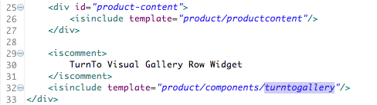

1. If you want bundles and product sets to have the widgets too, add the same code snippet to the following template in your storefront cartridge: *templates/default/product/producttopcontentPS.isml*

### Category and Search Pages

#### Refinements (optional)

**NOTE: You will need to have completed the "Configure Average Star Ratings as a Search Refinement" steps under "Configuration" for the refinements to show up.**

1. In UX Studio, open the following template in your storefront cartridge: *templates/default/search/components/productsearchrefinebar.isml*
2. Add the following code after the <isif> check for 'refinementColor', but before the <iselse/>:  
     
   <iselseif condition="${RefinementDefinition.attributeID.equals('turntoAverageRating')}">  
     
   <isinclude template="product/components/turntoratingrefinement"/>  
     
   The result will look like this:

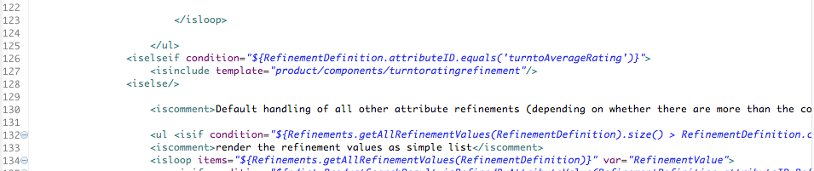

#### Product Tile Teaser (optional)

**NOTE: The necessary product data comes from the SKU-to-Average-Rating Feed.**

In UX Studio, open the following template in your storefront cartridge: *templates/default/product/components/reviewsmini.isml*

Replace the code inside the div with class="product-review" with the following:  
  
<isinclude template="product/components/turntoteasersproducttile"/>  
  
The result will look like this:

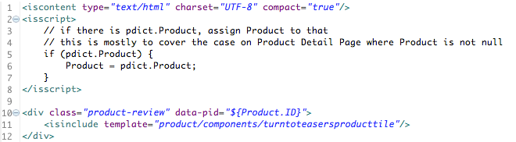

#### Checkout Comments Pinboard Teaser (optional)

1. In UX Studio, open the following template in your storefront cartridge: *templates/default/rendering/category/catlanding.isml*
2. Put the following code snippet wherever you would like the teaser to appear, likely somewhere in the div with class="secondary-content":

<iscomment>TurnTo CCheckout Comments Pinboard Teaser</iscomment>  
<isinclude template="product/components/turntopinboardteaser"/>  
  
The result will look like this:

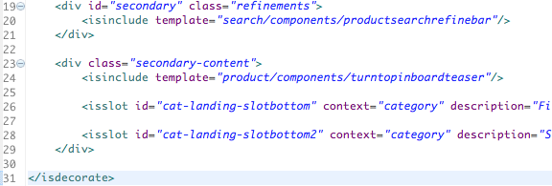

1. Add the same snippet to the other category page as well: *templates/default/rendering/category/categoryproducthits.isml*

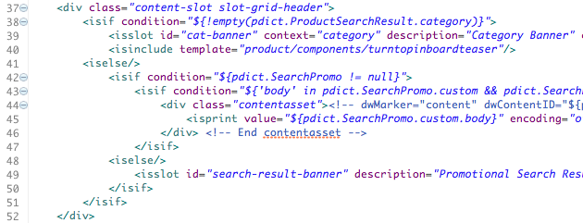



1. Add the snippet to the homepage as well: *templates/default/content/home/homepage.isml*

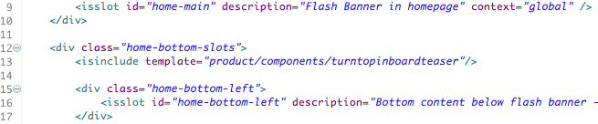

1. A few things to note about the CC Pinboard Teaser:
   1. For ALL pages, the teaser will only show if there are at least 4 products that have 4 buyer comments each
   2. On the home page, or a page without a pdict.ProductSearchResult.category, all products sitewide will be considered for display
   3. On a category page, only the products that belong to that category (defined in the Catalog Feed) will be considered for display
   4. On a category page, only the categories that have the custom attribute turntoEnableCCPinboardTeaser set to true will actually render the teaser,

#### Single Sign On (SSO) (Optional)

TurnTo requires that some user actions, such as answering a question, can only be done by a logged-in user. TurnTo has its own authentication system that will display a registration screen to the user of the widgets when appropriate. If you instead choose to use your site’s authentication / registration functionality so that users who are already logged into your site do not need to register again when using the TurnTo widgets, you can make use of the TurnTo single sign-on (SSO) features. The following describes how TurnTo integrates with your site to implement SSO as part of the TurnTo UGC workflow.

1. To enable SSO, all that is to set the site preference “turnToSSOEnable” to true.
2. Once the site preference is set to true, the registration logic will be added to the TurnToConfig object in the header include file

*int\_turnto\_core/cartridge/templates/default/turnto/htmlheadincludejs.isml*

The result will look like this:

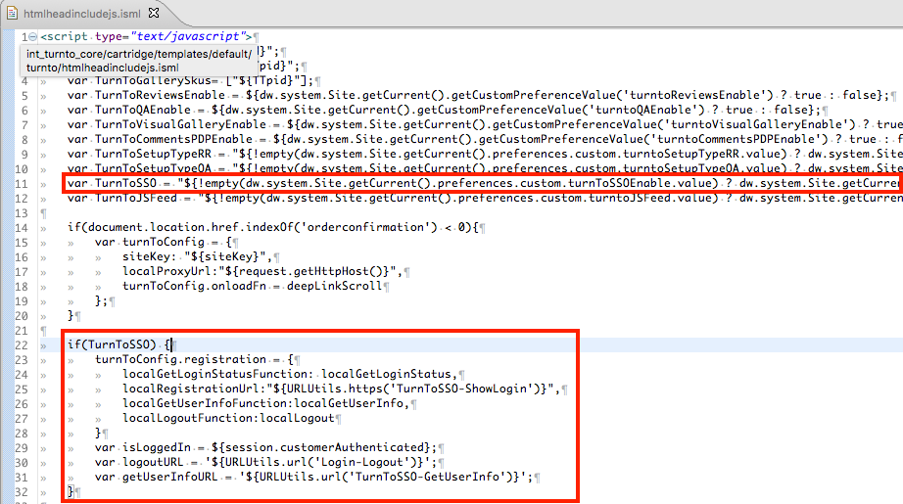

1. If you need to make modifications to the login page pop-up on the product detail page (PDP), look at the following template

*templates/default/account/loginpage.isml*

1. If the login submit button class is changed from the original base code then you will need to modify the JS event handler in the corresponding login JS file.
2. If you would like to add Shopper/Profile Attributes, you will need to see the following profile attributes section and complete step 6

**profile\_attributes:** An array of objects that have a ‘name’ and ‘value’ property. (e.g. [{“name”:”Speed”, “value”:”Fast”}] ). The name of each profile attribute should be the same as the “Profile Attribute Name” that you have set up in the “Shopper Profiles” area your site’s configuration portal on [www.turnto.com](http://www.turnto.com)

1. If you would like to add additional user profile attributes to be sent back to TurnTo then you will need to modify the function “GetUserInfo” in the following template along with the helper function “buildUserInfoObject” in the HelperUtil.js file.

*Int\_turnto\_controllers/cartridge/controllers/TurnToSSO.js*

**NOTE: The login pop-up isn’t opened until a question if submitted to TurnTo.**

**NOTE: In the context of your mobile site, the SSO-specific turnToConfig additions should be made on the TurnTo mobile landing page.**

1. Workflows

1.1 Asking or answering a question, logged out on TT, logged out on Partner - no server-side call

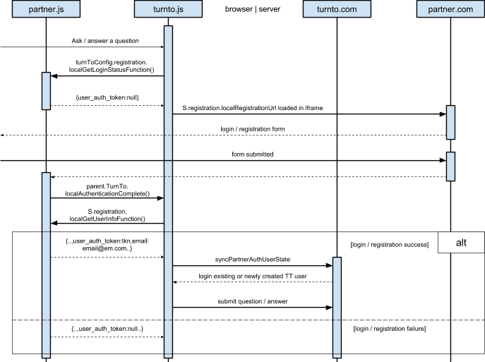

1.2 Asking or answering a question, logged-in on TT, logged out on Partner, no server-side call. This is the same scenario as when the user’s login session has expired on Partner.

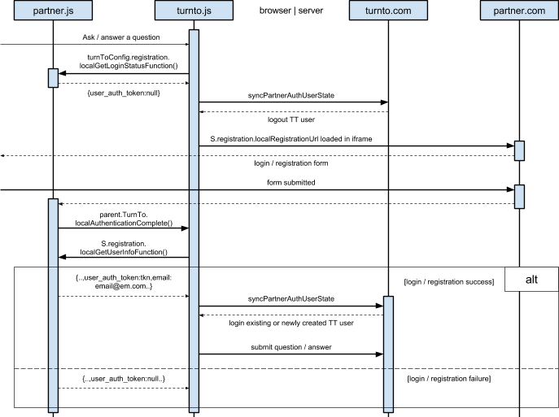

* 1. Asking or answering a question, logged-out on TT, logged in on Partner, no server-side call

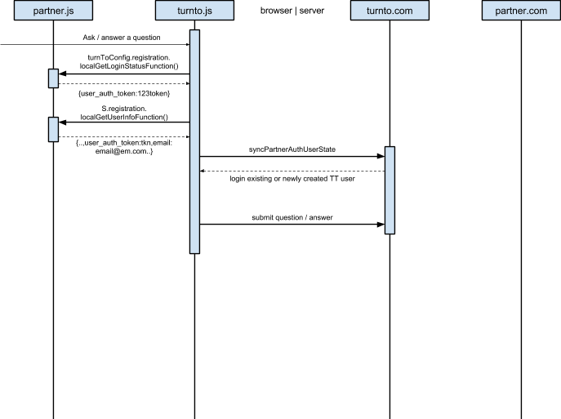

* 1. Asking or answering a question, logged-in on TT, logged in on Partner, no server-side call

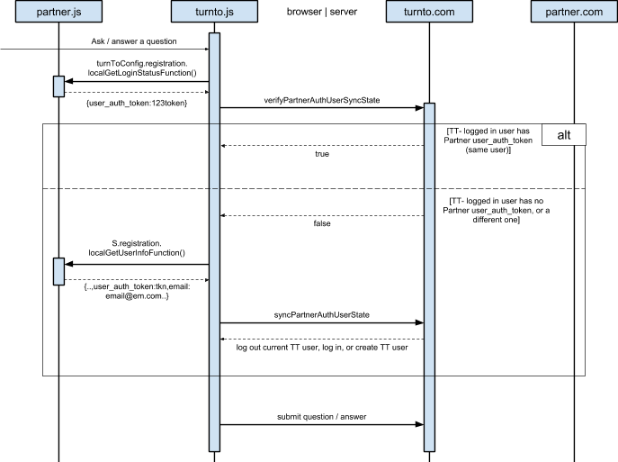

* 1. Clicking on link in Question email

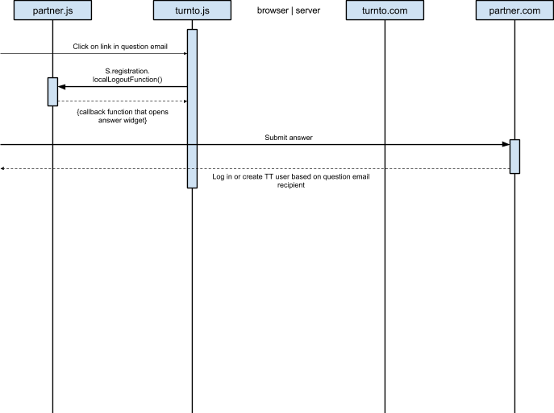

## Testing Use Cases

### Q&A Testing

In the “TurnToQ&A” Preferences group, enabled the Q&A Feature:



With this feature enabled, navigate to any product page and scroll near the bottom to see the Q&A module working:

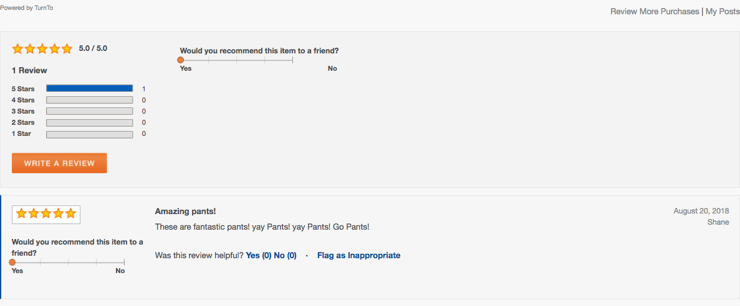

Submit a question on the PDP, then on the TurnTo console for the site being managed, selected “Moderate Q&A” from the menu and note the data in TurnTo:

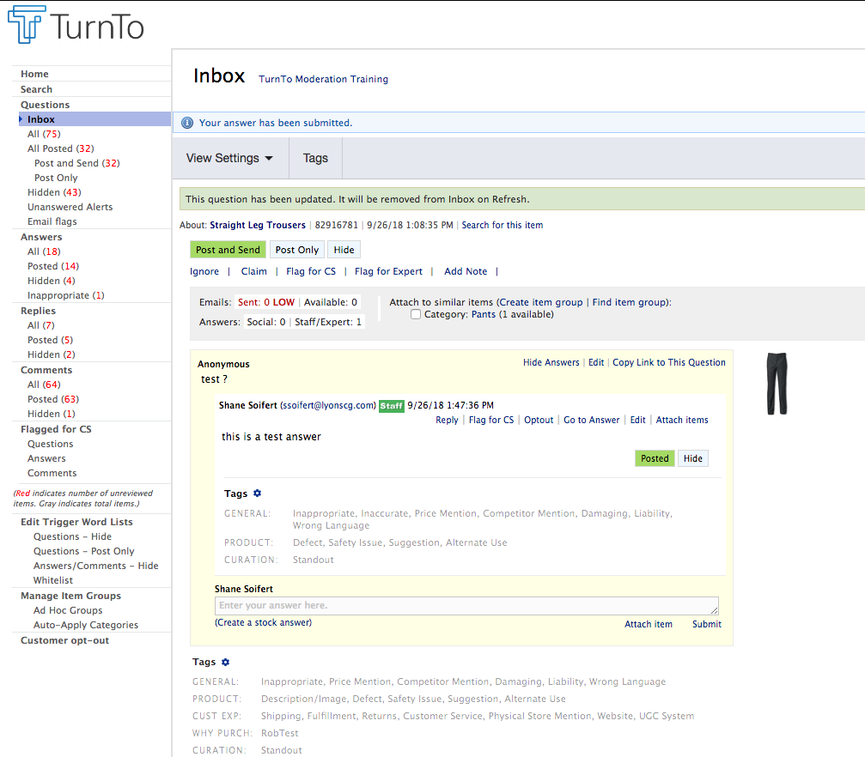

Select “show/add answers” and enter a new answer:

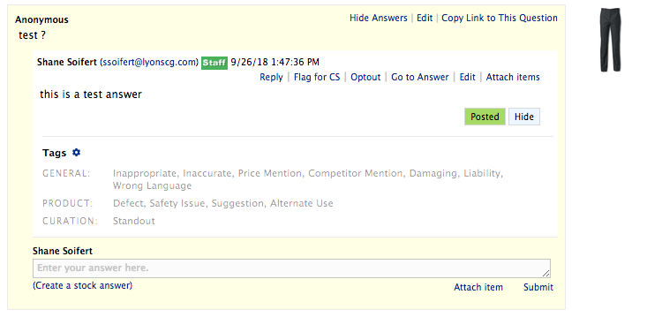

Refresh the PDP page and see the updated data delivered dynamically from TurnTo:

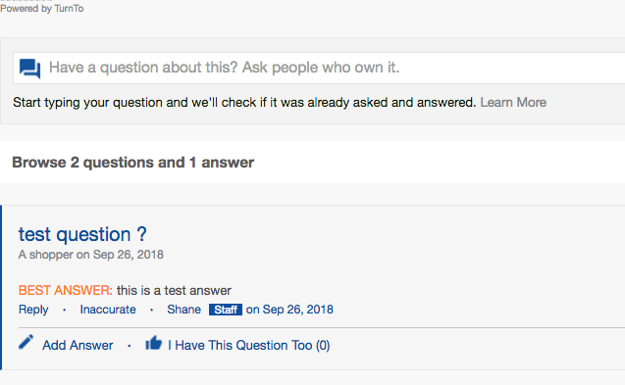

### Reviews Testing

1. Within the “TurntoReview” preference group, enable the Reviews widget for the PDP:

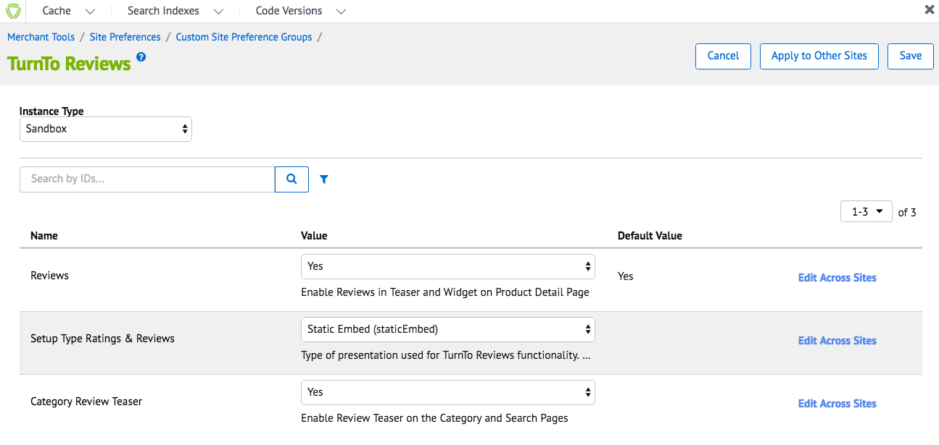

1. Navigate to the PDP and observe the teaser and review widget on the PDP:

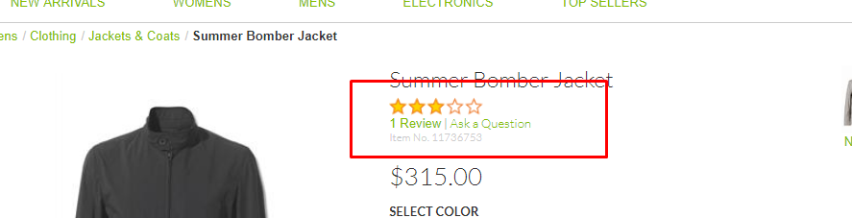



1. Click on Write a Review and populate some data:

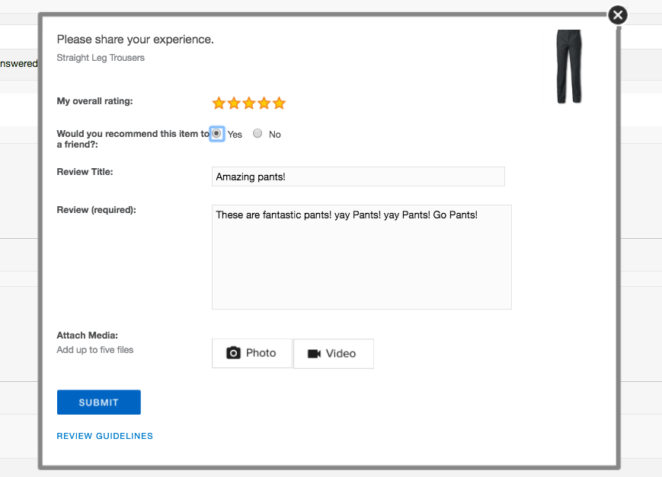

1. If you are logged into the storefront and have already submitted a review for a certain product, you will not see the “write a review” modal as in step 3, but instead see the following:

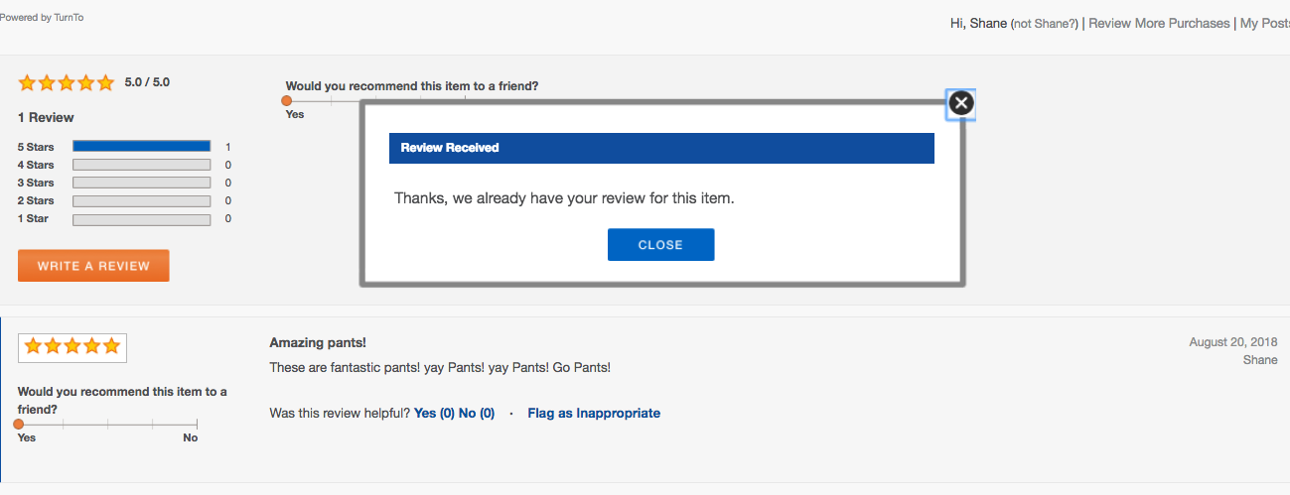

1. Within the TurnTo system, navigate to the site you are managing and select “Moderate Reviews” to see the data in TurnTo:

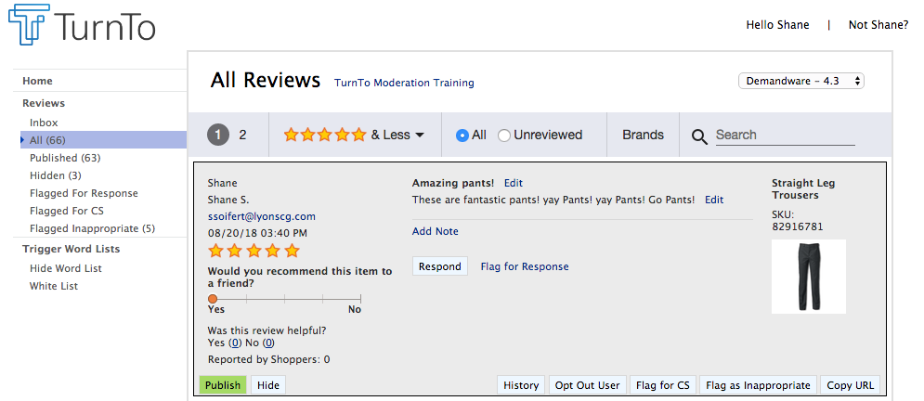

1. Click “Publish”
2. Then refresh the PDP to see the moderated review display on the PDP:

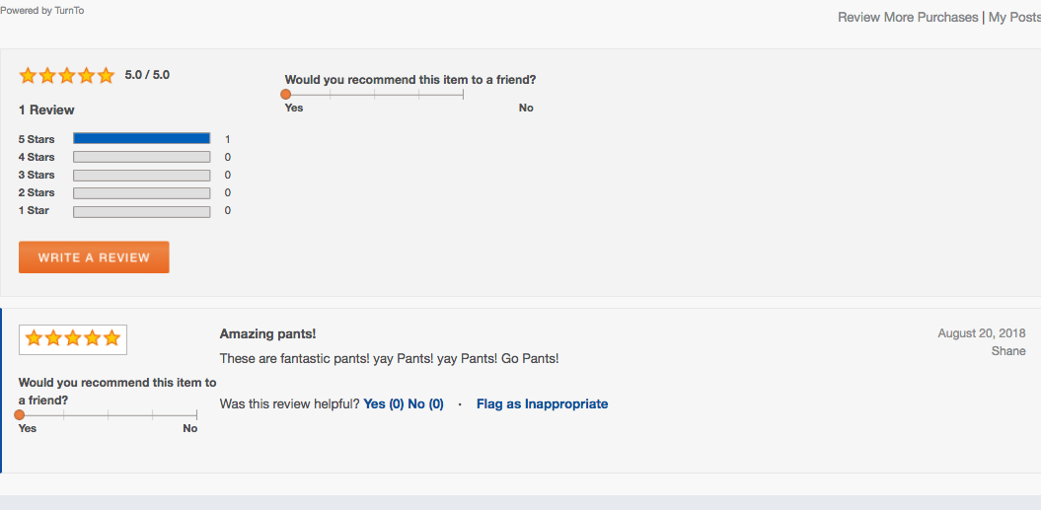

### Visual Content Testing

1. Enable the “TurnTo Visual Content” site preference feature:

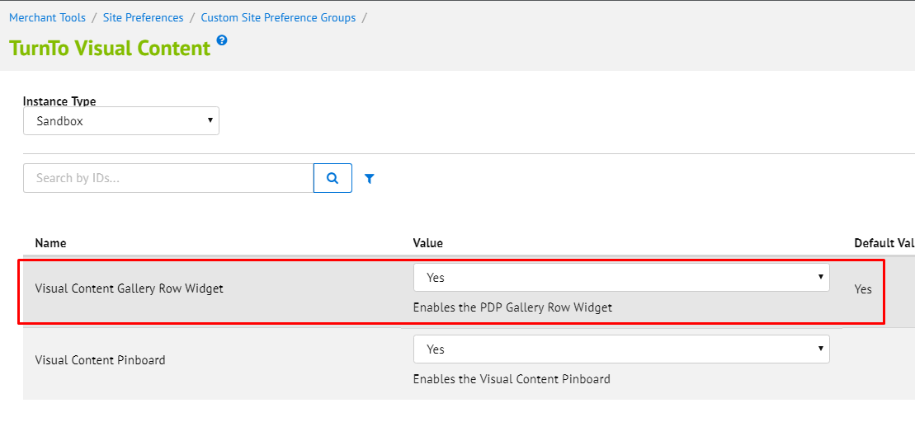

1. To show the PDP gallery row widget. Enable the TurnTo Gallery site preference and submit a review with images. Be sure to publish them on the TurnTo dashboard. 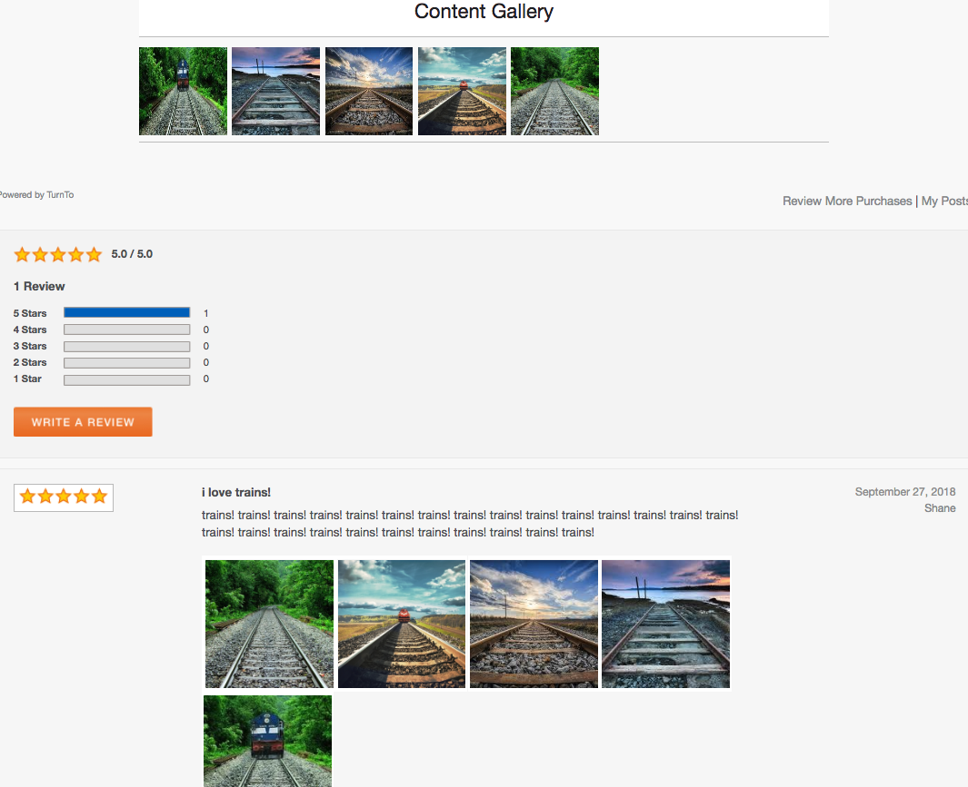
2. To show the TurnTo Pinboard, enable the TurnTo PinBoard feature through the site preference and navigate to:

**NOTE: The following URL will only work if Storefront URLs are turned OFF.**

<https://turntonetworks01-tech-prtnr-na01-dw.demandware.net/on/demandware.store/Sites-SiteGenesis-Site/en_US/TurnTo-VisualContentPinboard>

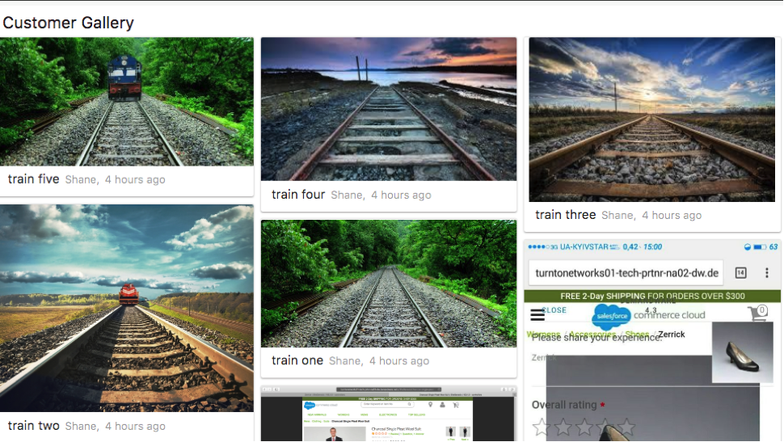

The PinBoard feature is moderated in the TurnTo console under “Moderate Visual Content”:

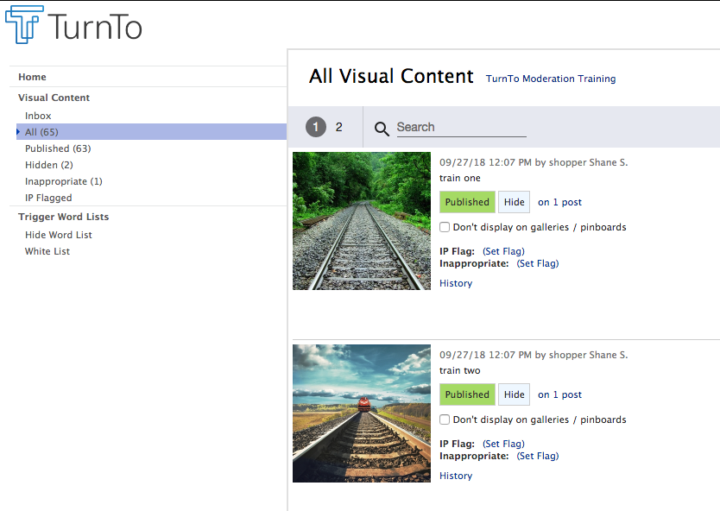

### Refinements Testing

1. Follow the guide steps in “Configure Average Star Ratings as a Search Refinement” to enable the TurnTo average rating for desired storefront catalog refinements.
2. After setup you will see the average rating refinement on search and category results page if one or more product(s) have at least one review.

### Checkout Comments

1. Within the “TurnTo Checkout Comments” site preference, enable the following feature:

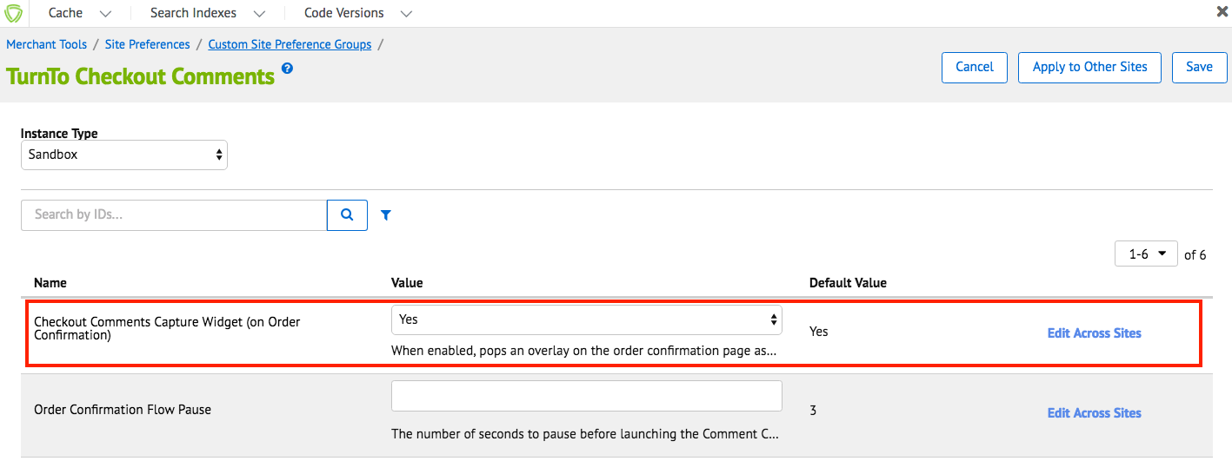

1. Place an order on the storefront and observe the checkout comments module:

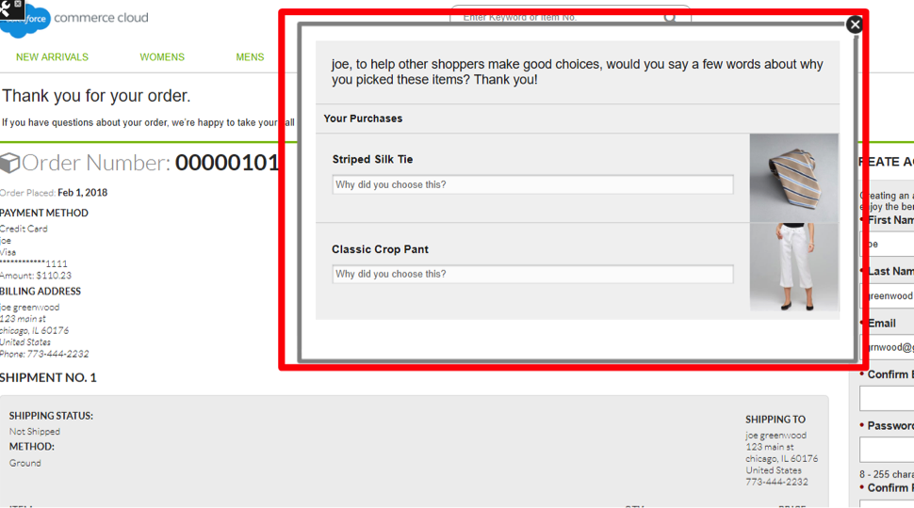

To test any of the specific other checkout comment features (category page, etc) see the installation guide above for the necessary criteria.